**SQL BI-WEEKLY ASSESSMENT**

**Instructions:**

It is important that all instructions are properly understood to allow a smooth running of this assessment.

Steps:

1. Go to your browser and click on the links as listed as your questions to answer.
2. Make sure to create an account and verify your email with Leetcode so you can be able to write the queries
3. Once you answer a question, copy the code you used into your system notepad and name each query you wrote with the number of the question answered e.g 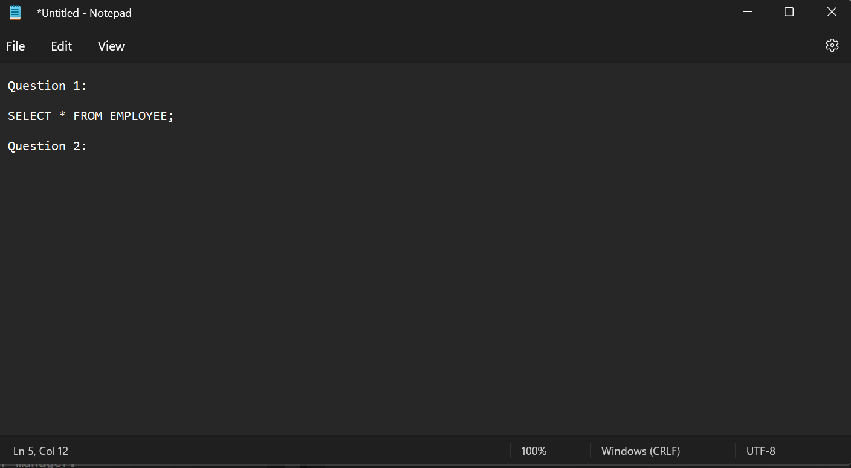
4. Once you copy all your questions and queries into the note pad, save it and name the notepad as “SQL BiWeekly Assessment”
5. Go to your classroom and add this notepad (.txt) document to your submission as a file
6. Then when you’re done with this, you can go ahead and submit it.

**QUESTIONS:**

1. <https://leetcode.com/problems/employees-earning-more-than-their-managers/description/>
2. <https://leetcode.com/problems/delete-duplicate-emails/>
3. <https://leetcode.com/problems/customers-who-never-order/>
4. <https://leetcode.com/problems/swap-salary/>
5. <https://leetcode.com/problems/user-activity-for-the-past-30-days-i/>
6. <https://leetcode.com/problems/group-sold-products-by-the-date/>
7. <https://leetcode.com/problems/sales-analysis-iii/>

Even if there are solutions there, for your best sake, make sure you submit your own answers so you can know where you need to improve.

**ALL QUESTIONS SHOULD BE DIRECTED TO EKELE JINAWA**